ODS Database Schema and UI validation Changes

|  |  |  |  |  |
| --- | --- | --- | --- | --- |
| **DataBase Schema details for ODS** | | | | |
| **Table Name** | **ColumnName** | **Size** | **Changes Required** | **Comments** |
| tblClinicalCommissioningGroup | CCG_Identifier | Varchar(5) | __ |  |
| tblClinicalCommissioningGroup_Audit |
| tblEpisode | Referrer_CCG_Code | Varchar(5) | __ | Changes are done in CN-6483 |
| tblEpisode_Audit |
| tblReferral | Referrer_CCG_Code | Varchar(5) | __ | Changes are done in CN-6483 |
| tblReferral_Audit |
| tblSLAMCareOptionOverride | Override_GP_CCG_Code,Override_Patient_CCG_Code | varcha(10) | __ |  |
| tblSLAMCareOptionOverride_Audit |
| tblSLAMCareOptionPart2 | Referral_CCG_Code | varcha(10) | __ |  |
| tblSLAMCareOptionPart2_Audit |
| tblCWPNTElectronicDischargeSummary | GP_Practice_Code | varcha(20) | __ |  |
| tblCWPNTElectronicDischargeSummary_Audit |
| tblCWPNTFallsRiskAssessmentTool | GP_Practice_Code | varchar(20) | __ |  |
| tblCWPNTFallsRiskAssessmentTool_Audit |
| tblEpisode | Practice_Code | varchar(20) | __ |  |
| tblEpisode_Audit |
| tblPractice | Practice_Code | varchar(20) | __ |  |
| tblPractice_Audit |
| tblReferral | Practice_Code | varchar(20) | __ |  |
| tblReferral_Audit |
| tblSLAMCareOptionOverride | Override_Practice_Code | varchar(20) | __ |  |
| tblSLAMCareOptionOverride_Audit |
| tblSLAMCareOptionPart2 | Referral_Practice_Code | varchar(20) | *__* |  |
| tblSLAMCareOptionPart2_Audit |
| tblSLAMNDTMS | GP_Practice_Code | varchar(255) | *__* |  |
| tblSLAMNDTMS_Audit |
| tblSLAMYPNDTMS | GP_Practice_Code | varchar(255) | *__* |  |
| tblSLAMYPNDTMS_Audit |
| ChildHealthDBSResponse | RegisteredGpPractice | nvarchar(12) | *__* | This table is in ChildHealth DB and this table will be updated through DBS service |

* Also searched for CCG in Child Health, Waiting List but we didn't find the table which is having CCG. IN child health DB we found the Practice code
* Looked into PatientDemographicsService(DBS generator) it will update only patient personal details. But the Childheatlth DBS will update the Practice Code to the ChildHealthDBSResponse table
* There is no foreign key reference for CCG code, there is a CCG_ID which was internally craeted by carenotes that CCG_ID is referenced to various tables**.**
* There is no foreign key reference for practice code, there is a Practice_ID which was internally craeted by carenotes that practice_ID is referenced to various tables**.**

**UI Validation details**

**SLAMExternalPlacement.aspx**

It’s a read-only field no need to change and there is no validations.

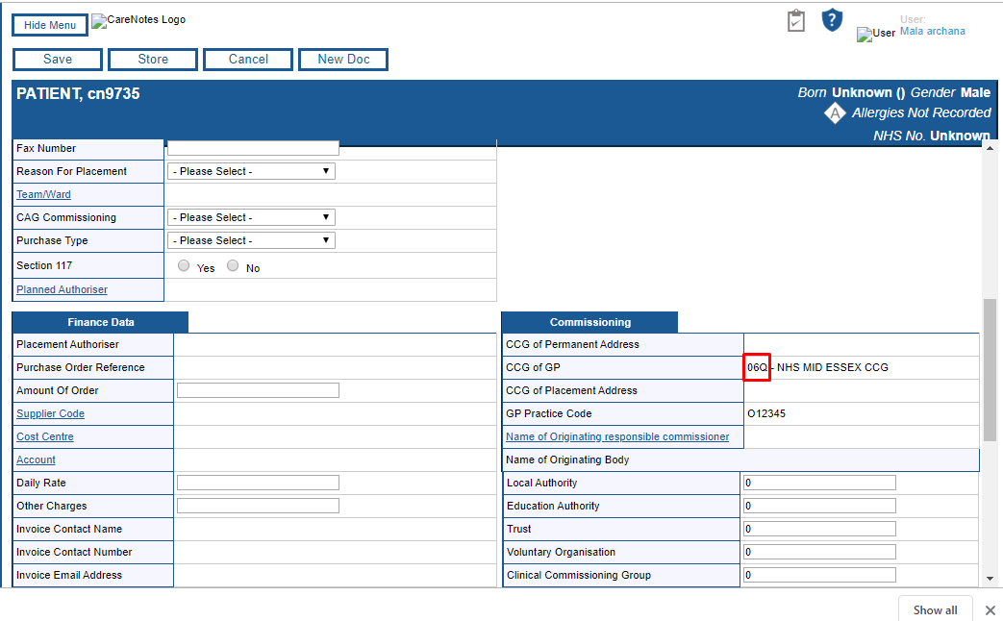

**CCG.aspx**

<asp:TextBox ID="CCGIdentifier" Width="50px" runat="server**" MaxLength="5"**></asp:TextBox>

The textfield max length has been restricted to 5 and there is no specific validations for CCG. general validations like mandatory field and checking for NULL exists.

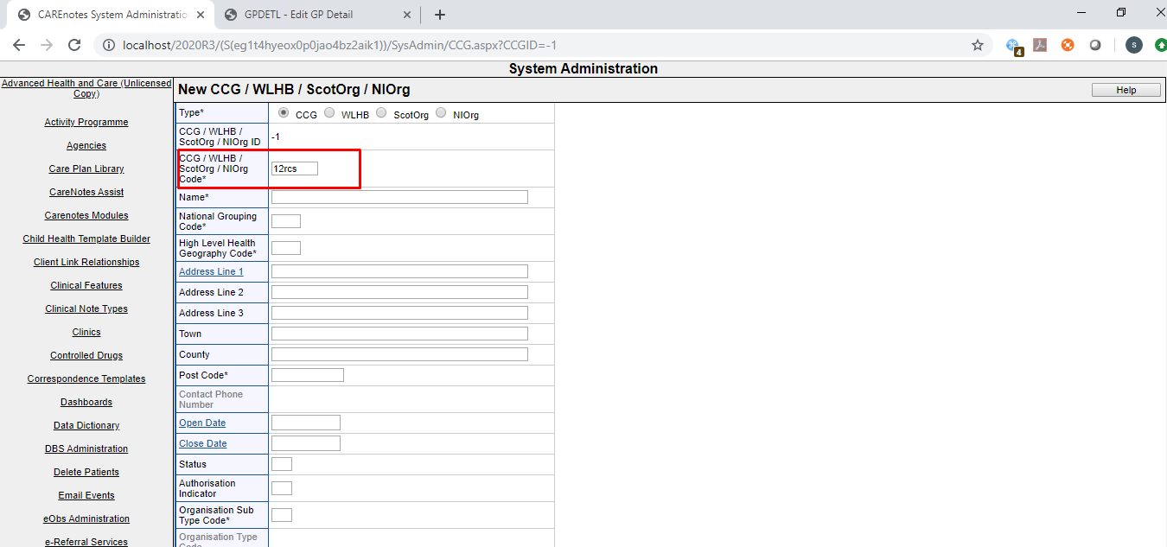

**ReferralDetails.ascx**

<asp:TextBox ID="ReferrerCCGCode" class="ReferralDetailsSection_ReferrerCCGCode" runat="server" Width="20" **MaxLength="10"**></asp:TextBox>

CCG will be autopopulated in the referral and Different Episode form when we click RegGP button we may need to change the CCG textbox size to display the CCG which has 5 character completely there is no specific validations here

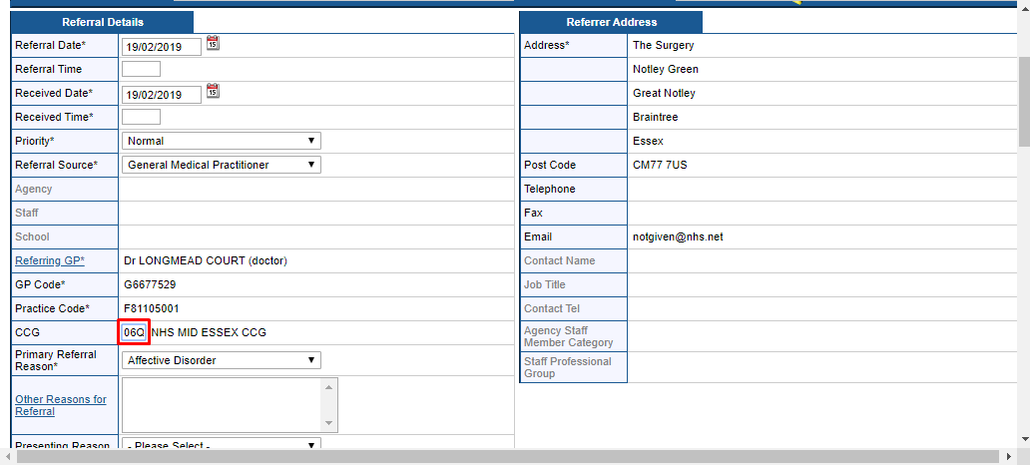

**SystemAdministaration\Location.aspx**

There is no validations for CCG. Works fine with 5character CCG

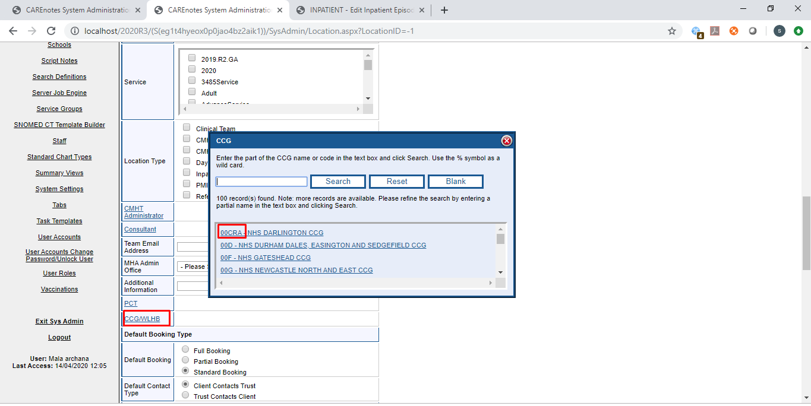

**S**[**LAM Inpatient Care Option**](javascript:%20EditForm(198);)**:**

The CCG id in the form is hidden and it can have 5 characters CCG id and there is no specific validations for CCG

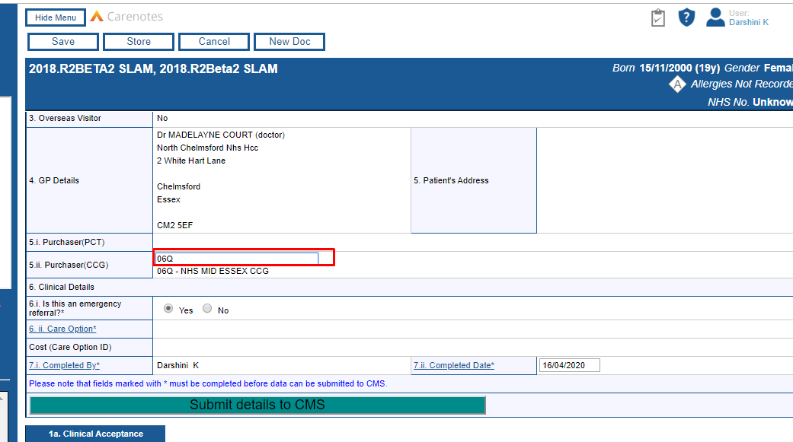

* Similarly we have the CCG for SLAM Outpatient daycareoption form

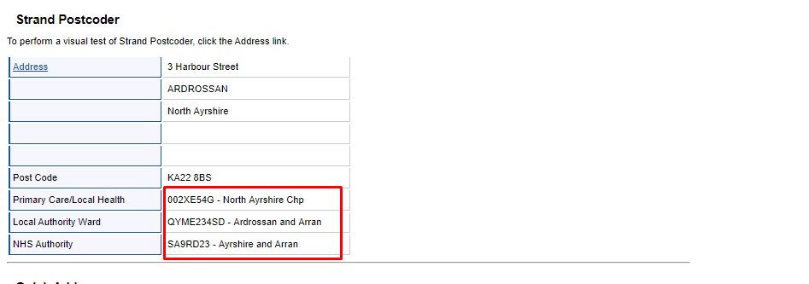

Local Authority organisation

The text box length is restricted to 3 character.

The value(LA_ORG_Identifier) will be stored in the table tblLocalAuthorityOrganisation and the size of the column is Varchar(5)

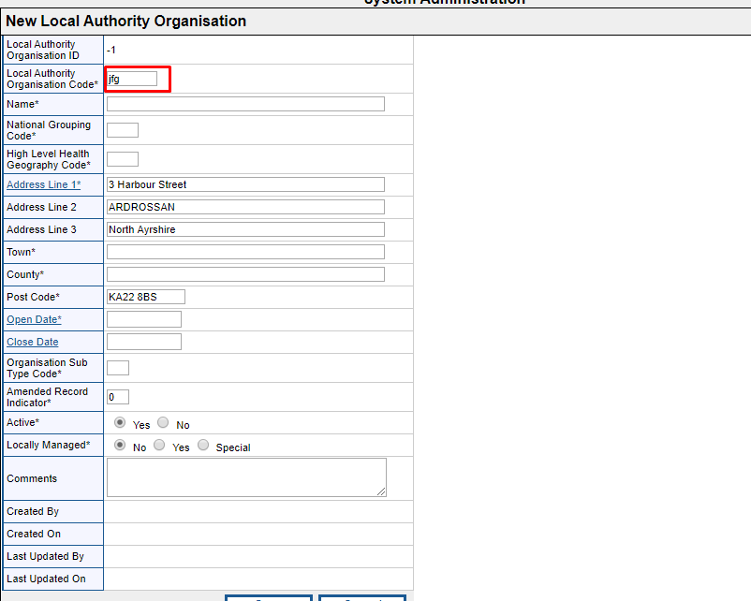

**Database mapping**

|  |  |  |
| --- | --- | --- |
| **csv File** | **Stored Procedure** | **Tables List** |
| niorg.csv | usp_UpdateClinicalCommissioningGroup, usp_UpdateClinicalCommissioningGroupPractice | tblClinicalCommissioningGroup, tblPractice, tblClinicalCommissioningGroupPractice |
| epctcur.csv | usp_UpdatePCT | tblPCT |
| npraccur.csv | usp_UpdatePractice | tblPractice, tblGPPractice |
| scotprac.csv | usp_UpdatePractice | tblPractice, tblGPPractice |
| epraccur.csv | usp_UpdatePractice | tblPractice, tblGPPractice |
| ebranchs.csv | usp_UpdatePractice | tblPractice, tblGPPractice |
| ngpcur.csv | usp_UpdateGP | tblGP, tblGPPractice |
| scotgp.csv | usp_UpdateGP | tblGP, tblGPPractice |
| egpcur.csv | usp_UpdateGP | tblGP, tblGPPractice |
| scotorg.csv | usp_UpdateClinicalCommissioningGroup, usp_UpdateClinicalCommissioningGroupPractice | tblClinicalCommissioningGroup, tblPractice, tblClinicalCommissioningGroupPractice |
| eccg.csv | usp_UpdateClinicalCommissioningGroup, usp_UpdateClinicalCommissioningGroupPractice | tblClinicalCommissioningGroup, tblPractice, tblClinicalCommissioningGroupPractice |
| wlhb.csv | usp_UpdateClinicalCommissioningGroup, usp_UpdateClinicalCommissioningGroupPractice | tblClinicalCommissioningGroup, tblPractice, tblClinicalCommissioningGroupPractice |
| epcmem.csv | usp_UpdateClinicalCommissioningGroup, usp_UpdateClinicalCommissioningGroupPractice | tblClinicalCommissioningGroup, tblPractice, tblClinicalCommissioningGroupPractice |
| nlhscgpr.csv | usp_UpdateClinicalCommissioningGroup, usp_UpdateClinicalCommissioningGroupPractice | tblLocalAuthorityOrganisation |

**Lauth.csv**

**tblLocalAuthorityOrganisation**

**"012","ISLE OF ANGLESEY UA","W00","Q99","COUNCIL OFFICES","","","LLANGEFNI","GWYNEDD","LL77 7TW","19960401","","","H","","","","","","","","0","","","","",""**







**<Organisation orgRecordClass="RC1">**

**<Name>ISLE OF ANGLESEY UA</Name>**

**<Date>**

**<Type value="Operational" />**

**<Start value="1996-04-01" />**

**</Date>**

**<OrgId root="2.16.840.1.113883.2.1.3.2.4.18.48" assigningAuthorityName="HSCIC" extension="012" />**

**<Status value="Active" />**

**<LastChangeDate value="2019-07-05" />**

**<GeoLoc>**

**<Location>**

**<AddrLn1>COUNCIL OFFICES</AddrLn1>**

**<Town>LLANGEFNI</Town>**

**<County>GWYNEDD</County>**

**<PostCode>LL77 7TW</PostCode>**

**<Country>WALES</Country>**

**</Location>**

**</GeoLoc>**

**<Roles>**

**<Role id="RO40" uniqueRoleId="174365">**

**<Date>**

**<Type value="Operational" />**

**<Start value="2013-10-01" />**

**</Date>**

**<Status value="Active" />**

**</Role>**

**<Role id="RO141" uniqueRoleId="23494" primaryRole="true">**

**<Date>**

**<Type value="Operational" />**

**<Start value="1996-04-01" />**

**</Date>**

**<Status value="Active" />**

**</Role>**

**</Roles>**

**<Succs>**

**<Succ uniqueSuccId="32885">**

**<Date>**

**<Type value="Legal" />**

**<Start value="1996-04-01" />**

**</Date>**

**<Type>Predecessor</Type>**

**<Target>**

**<OrgId root="2.16.840.1.113883.2.1.3.2.4.18.48" assigningAuthorityName="HSCIC" extension="004" />**

**<PrimaryRoleId id="RO141" uniqueRoleId="57129" />**

**</Target>**

**</Succ>**

**<Succ uniqueSuccId="37104">**

**<Date>**

**<Type value="Legal" />**

**<Start value="2013-04-01" />**

**</Date>**

**<Type>Predecessor</Type>**

**<Target>**

**<OrgId root="2.16.840.1.113883.2.1.3.2.4.18.48" assigningAuthorityName="HSCIC" extension="V410" />**

**<PrimaryRoleId id="RO119" uniqueRoleId="113182" />**

**</Target>**

**</Succ>**

**</Succs>**

**</Organisation>**

**Ebranches.csv**

**npraccur.csv**

**tblPractice**

**"A82030001","WEST VIEW SURGERY","Y62","Q84","LANCASTER ROAD","HORNBY","","LANCASTER","LANCASHIRE","LA2 8JS","20050401","","","","A82030","20050401","","","","","","0","","B","","",""**

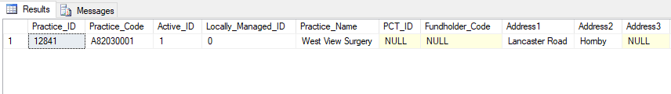



<Organisation orgRecordClass="RC2">

<Name>WEST VIEW SURGERY</Name>

<Date>

<Type value="Operational" />

<Start value="2005-04-01" />

</Date>

<OrgId root="2.16.840.1.113883.2.1.3.2.4.18.48" assigningAuthorityName="HSCIC" extension="A82030001" />

<Status value="Active" />

<LastChangeDate value="2016-05-05" />

<GeoLoc>

<Location>

<AddrLn1>LANCASTER ROAD</AddrLn1>

<AddrLn2>HORNBY</AddrLn2>

<Town>LANCASTER</Town>

<County>LANCASHIRE</County>

<PostCode>LA2 8JS</PostCode>

<Country>ENGLAND</Country>

</Location>

</GeoLoc>

<Roles>

<Role id="RO96" uniqueRoleId="31880" primaryRole="true">

<Date>

<Type value="Operational" />

<Start value="2005-04-01" />

</Date>

<Status value="Active" />

</Role>

</Roles>

<Rels>

<Rel id="RE6" uniqueRelId="21444">

<Date>

<Type value="Operational" />

<Start value="2005-04-01" />

</Date>

<Status value="Active" />

<Target>

<OrgId root="2.16.840.1.113883.2.1.3.2.4.18.48" assigningAuthorityName="HSCIC" extension="A82030" />

<PrimaryRoleId id="RO177" uniqueRoleId="88114" />

</Target>

</Rel>

</Rels>

</Organisation>

**Eccg.csv**

**tblClinicalCommissioningGroup**

**"01A","NHS EAST LANCASHIRE CCG","Y62","Q84","WALSHAW HOUSE","REGENT STREET","","NELSON","","BB9 8AS","20130401","","","C","","","","","","","","1","","","","",""**









<Organisation orgRecordClass="RC1">

<Name>NHS EAST LANCASHIRE CCG</Name>

<Date>

<Type value="Legal" />

<Start value="2013-04-01" />

</Date>

<Date>

<Type value="Operational" />

<Start value="2011-12-13" />

</Date>

<OrgId root="2.16.840.1.113883.2.1.3.2.4.18.48" assigningAuthorityName="HSCIC" extension="01A" />

<Status value="Active" />

<LastChangeDate value="2019-06-14" />

<GeoLoc>

<Location>

<AddrLn1>WALSHAW HOUSE</AddrLn1>

<AddrLn2>REGENT STREET</AddrLn2>

<Town>NELSON</Town>

<County>LANCASHIRE</County>

<PostCode>BB9 8AS</PostCode>

<Country>ENGLAND</Country>

</Location>

</GeoLoc>

<Roles>

<Role id="RO98" uniqueRoleId="161406" primaryRole="true">

<Date>

<Type value="Legal" />

<Start value="2013-04-01" />

</Date>

<Date>

<Type value="Operational" />

<Start value="2011-12-13" />

</Date>

<Status value="Active" />

</Role>

</Roles>

<Rels>

<Rel id="RE5" uniqueRelId="186163">

<Date>

<Type value="Legal" />

<Start value="2013-04-01" />

<End value="2015-03-31" />

</Date>

<Date>

<Type value="Operational" />

<Start value="2012-10-01" />

<End value="2015-03-31" />

</Date>

<Status value="Inactive" />

<Target>

<OrgId root="2.16.840.1.113883.2.1.3.2.4.18.48" assigningAuthorityName="HSCIC" extension="Q47" />

<PrimaryRoleId id="RO210" uniqueRoleId="163542" />

</Target>

</Rel>

<Rel id="RE5" uniqueRelId="343236">

<Date>

<Type value="Operational" />

<Start value="2015-04-01" />

<End value="2016-03-31" />

</Date>

<Status value="Inactive" />

<Target>

<OrgId root="2.16.840.1.113883.2.1.3.2.4.18.48" assigningAuthorityName="HSCIC" extension="Q73" />

<PrimaryRoleId id="RO210" uniqueRoleId="202015" />

</Target>

</Rel>

<Rel id="RE5" uniqueRelId="525903">

<Date>

<Type value="Operational" />

<Start value="2017-04-01" />

<End value="2019-03-28" />

</Date>

<Status value="Inactive" />

<Target>

<OrgId root="2.16.840.1.113883.2.1.3.2.4.18.48" assigningAuthorityName="HSCIC" extension="69820" />

<PrimaryRoleId id="RO173" uniqueRoleId="230662" />

</Target>

</Rel>

<Rel id="RE5" uniqueRelId="450149">

<Date>

<Type value="Operational" />

<Start value="2016-04-01" />

</Date>

<Status value="Active" />

<Target>

<OrgId root="2.16.840.1.113883.2.1.3.2.4.18.48" assigningAuthorityName="HSCIC" extension="Q84" />

<PrimaryRoleId id="RO210" uniqueRoleId="278955" />

</Target>

</Rel>

</Rels>

</Organisation>

**Egpcur.csv**

**tblGP**

**G0102926,ANDERSON MG,Y55,Q79,LENSFIELD MEDICAL PRAC.,48 LENSFIELD ROAD,CAMBRIDGE,,,CB2 1EH,19740401,,A,O,D81001,19740401,19911231,0844 3878222,,,,0,,06H**



